

Pain relief for IUD insertion

The experience of pain during IUD insertion can be highly variable. Many people tolerate insertion of an IUD well, and the routine recommended analgesia is NSAIDs taken before the procedure to reduce cramping after the procedure. Recent social media attention in Aotearoa and overseas has highlighted experiences of severe pain and inadequate provision of pain relief and this coverage may present barriers to IUD uptake, and increase anxiety and anticipation of pain amongst people undergoing IUD placement or removal (Bayer et al 2025, Caddy et al 2025, Women’s Health Action 2024).

It is critical that if a person asks you to stop at any point you recognise that consent has been withdrawn and you stop the procedure.
We recommend that you:
- refresh your knowledge of trauma-informed care
  - A webinar by Dr Bronwyn Moore (September 2025) is available here
- use slow movements when placing a tenaculum
- consider how you communicate with the person during the procedure (vocal local/ verbal analgesia)
  - calming, comforting and distracting slow speech during the procedure using a soft, low-pitched voice
  - use of words to describe the procedure; for example ‘pinch’, ‘pain’ and ‘sore’ may heighten the pain experience, while ‘uncomfortable’ and ‘less comfortable’ may have a more positive effect

A number of studies (see reviews by Bayer et al 2025 and Sheffield et al 2025) have shown that people experience less pain with additional analgesia. In primary care this will add an additional cost that will need to be considered and discussed before the procedure. Pain relief options in addition to NSAIDs include:
- Lidocaine 2% gel is available on PSO. Placing it into the vagina before the speculum may help overall in the experience for the person but it will not impact the IUD insertion related pain
- Local anaesthetic creams/gels EMLA (Eutectic Mixture of Local Anaesthetics: lidocaine and prilocaine) and Ametop (4% tetracaine) applied topically to the cervix have been shown to reduce pain with tenaculum placement and IUD insertion. However, the cream needs to be on the cervix for 7 minutes to take effect and is not funded for this purpose.
- Lidocaine spray (as used for the back of the throat for endoscopy) has been shown to reduce pain at insertion of IUD. Note that it is not funded in the community and there are issues with the sterility of repeated uses requiring multiple glove changes.
- Intracervical 1% lignocaine 2mls injected at the site of tenaculum reduces pain associated with tenaculum placement.
- A paracervical block has been shown to reduce pain with IUD insertion
  - This video explains how to do a paracervical block
- Misoprostol is only indicated when there has been a prior failure to insert an IUD.

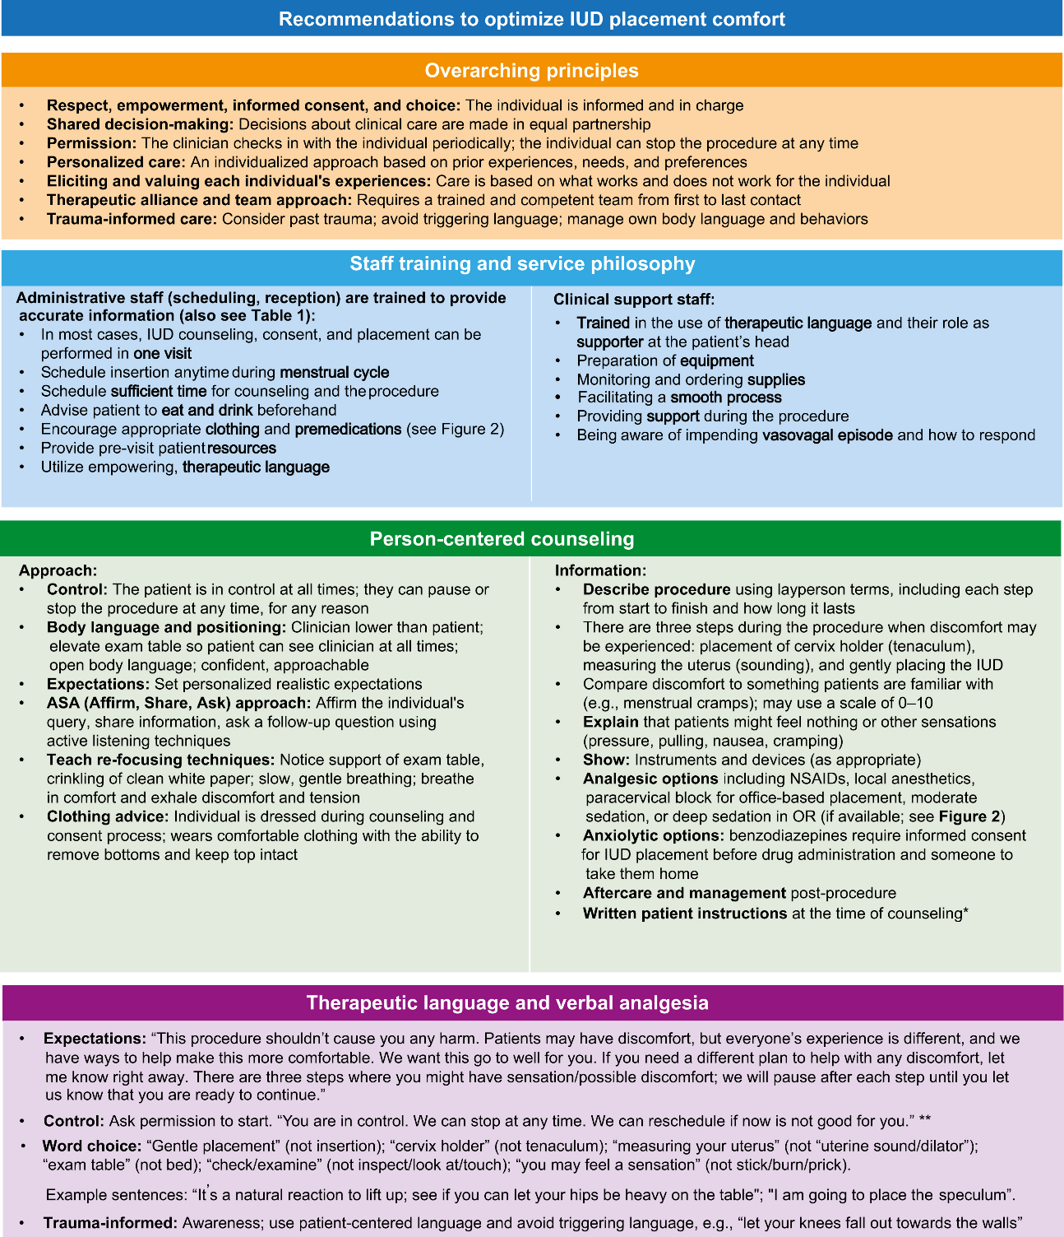
Above: Recommendations for training, service philosophy, counselling, and language for IUD placement. Reproduced from Bayer et al 2025. ∗If not same-day insertion. ∗∗Discuss backup contraception. IUD, intrauterine device; NSAID, nonsteroidal anti-inflammatory drug; OR, operating room.

Recommended reading:
Bayer, L L., S. Ahuja, R. H. Allen, M. A. Gold, J. P. Levine, L. L. Ngo, and S. Mody. 2025. ‘Best Practices for Reducing Pain Associated with Intrauterine Device Placement.’ American Journal of Obstetrics and Gynecology 232 (5): 409–21. https://doi.org/10.1016/j.ajog.2025.01.039 [OPEN ACCESS]
Caddy, C., M. Temple-Smith and J. Coombe. 2025. ‘Do Women Feel Unprepared for the Experience of an Intrauterine Device Insertion: Findings From an Australian Study.’ Perspectives on Sexual and Reproductive Health 57: 368–373. https://doi.org/10.1111/psrh.70023 [OPEN ACCESS]
Sheffield, S. M., A. Gilbert, K. R. Chang, S. K. Dotters-Katz, E. I. Gleeson, J. M. Hagey, Jill and N. P. Kerner. 2025. ‘Pain Management for IUD Insertion: A Review of the Clinical Evidence on Pharmacologic and Nonpharmacologic Options’. Obstetrical & Gynecological Survey 80:516-529 https://doi.org/10.1097/OGX.0000000000001417
Women’s Health Action. 2024. ‘IUD experiences in Aotearoa’ Available from: https://www.womens-health.org.nz/iuds/

